**Task2**

**Project: Student Database Management System(PostgreSQL)**

Objective: Design and implement a student database management system using PostgreSQL that allows storing and retrieving student information efficiently. The project will include the following tasks:

**1. Database Setup**

Create a database named "student_database."

Create a table called " student_table " with the following columns: Student_id (integer), Stu_name (text), Department (text), email_id (text ),Phone_no (numeric), Address (text), Date_of_birth (date), Gender (text), Major (text), GPA (numeric),Grade (text) should be A,B,C etc.

CREATE DATABASE student_database;

CREATE TABLE student_table (

Student_id SERIAL PRIMARY KEY, -- Auto-incrementing integer ID

Stu_name TEXT NOT NULL, -- Student name (text, cannot be NULL)

Department TEXT NOT NULL, -- Department name (text, cannot be NULL)

email_id TEXT UNIQUE, -- Email ID (unique constraint)

Phone_no NUMERIC, -- Phone number (numeric, optional)

Address TEXT, -- Address (text, optional)

Date_of_birth DATE, -- Date of birth (date, optional)

Gender TEXT, -- Gender (text, optional)

Major TEXT, -- Major (text, optional)

GPA NUMERIC, -- GPA (numeric, optional)

Grade TEXT CHECK (Grade IN ('A', 'B', 'C', 'D', 'E', 'F')) -- Grade (text with check constraint)

);

Output:

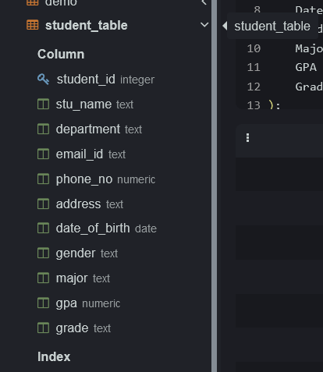

**2. Data Entry**

Insert 10 sample records into the "student_table" using INSERT command.

Code:

INSERT INTO student_table (Student_id, Stu_name, Department, email_id, Phone_no, Address, Date_of_birth, Gender, Major, GPA, Grade)

VALUES

(1, 'John Doe', 'Computer Science', 'john.doe@example.com', 1234567890, '123 Main St, Anytown, USA', '1995-05-15', 'Male', 'Computer Science', 3.8, 'A'),

(2, 'Jane Smith', 'Electrical Engineering', 'jane.smith@example.com', 9876543210, '456 Elm St, Othertown, USA', '1996-08-25', 'Female', 'Electrical Engineering', 3.5, 'B'),

(3, 'Alice Johnson', 'Biology', 'alice.johnson@example.com', NULL, '789 Oak Ave, Anothercity, USA', '1994-12-10', 'Female', 'Biology', 3.2, 'B'),

(4, 'Bob Brown', 'Mathematics', 'bob.brown@example.com', 5554443333, '567 Pine Rd, Somewhere, USA', '1997-02-28', 'Male', 'Mathematics', 3.9, 'A'),

(5, 'Emily Davis', 'History', 'emily.davis@example.com', 1112223333, '890 Maple Blvd, Anywhere, USA', '1993-09-05', 'Female', 'History', 3.6, 'B'),

(6, 'Michael Wilson', 'Physics', 'michael.wilson@example.com', 9998887777, '432 Birch Ln, Nowhere, USA', '1998-04-20', 'Male', 'Physics', 3.7, 'B'),

(7, 'Sophia Lee', 'Chemistry', 'sophia.lee@example.com', 6667778888, '654 Cedar Dr, Everywhere, USA', '1996-06-30', 'Female', 'Chemistry', 3.4, 'B'),

(8, 'David Martinez', 'Political Science', 'david.martinez@example.com', NULL, '321 Oakwood Ave, Noway, USA', '1995-03-12', 'Male', 'Political Science', 3.1, 'C'),

(9, 'Olivia Garcia', 'Economics', 'olivia.garcia@example.com', 7776665555, '789 Elmwood Rd, Somewhen, USA', '1997-11-18', 'Female', 'Economics', 3.8, 'A'),

(10, 'Daniel Rodriguez', 'Sociology', 'daniel.rodriguez@example.com', 4445556666, '876 Pinecrest Cir, Anyhow, USA', '1994-07-22', 'Male', 'Sociology', 3.3, 'B');

Output:

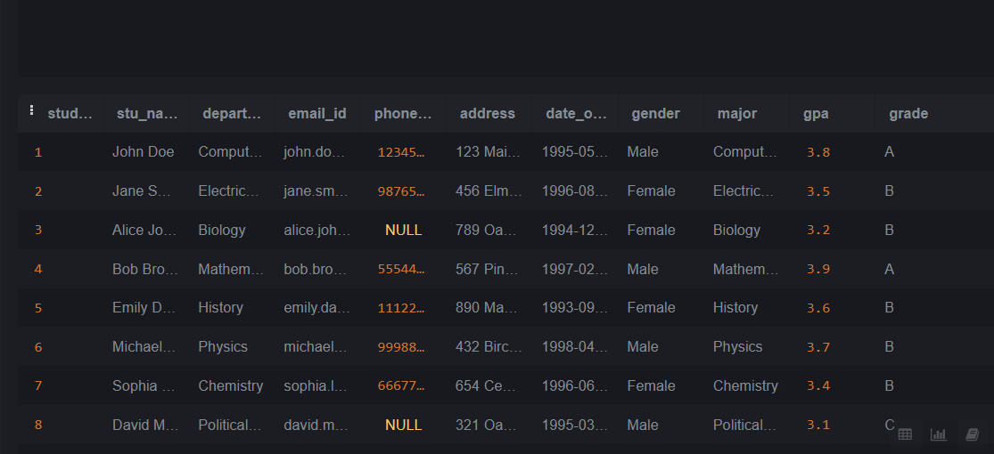

**3. Student Information Retrieval**

Develop a query to retrieve all students' information from the "student_table" and sort them in descending order by their grade.

**Code:**

SELECT *

FROM student_table

ORDER BY Grade DESC;

**Output:**

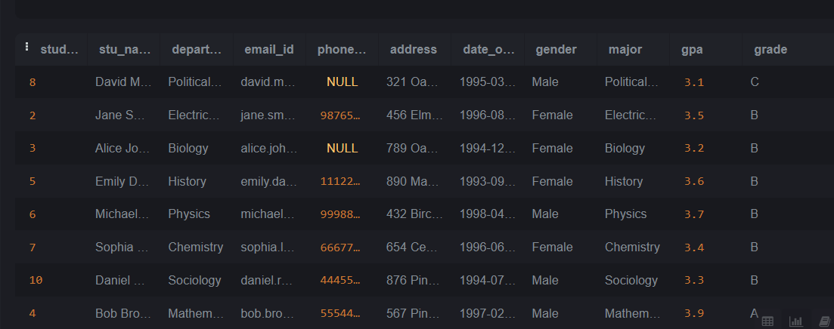

**4. Query for Male Students:**

.Implement a query to retrieve information about all male students from the "student_table."

Code:

SELECT *

FROM student_table

WHERE Gender = 'Male';

Output:

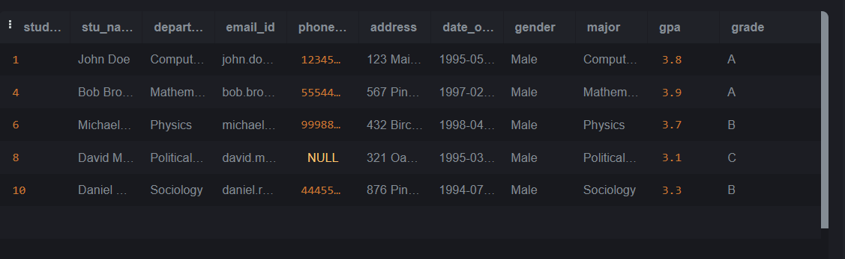

**5. Query for Students with GPA less than 5.0**

Create a query to fetch the details of students who have a GPA less than 5.0 from the "student_table."

Query:

SELECT *

FROM student_table

WHERE GPA < 5.0;

Output:

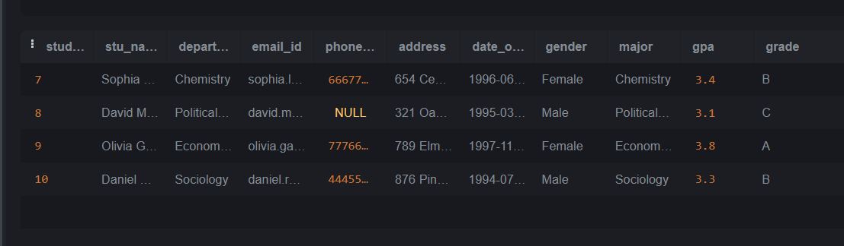

**6. Update Student Email and Grade**

Write an update statement to modify the email and grade of a student with a specific ID in the "student_table."

Query:

UPDATE student_table

SET email_id = 'jane.doe@example.com', Grade = 'B'

WHERE Student_id = 2;

Output:

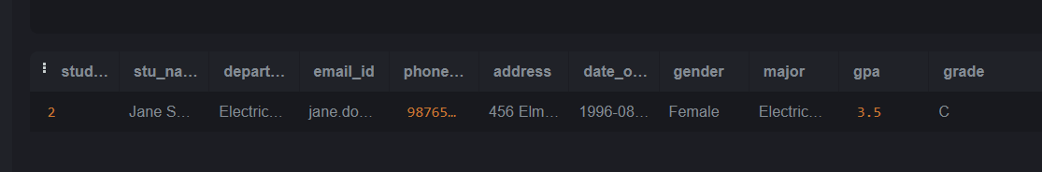

**7. Query for Students with Grade "B"**

Develop a query to retrieve the names and ages of all students who have a grade of "B" from the "student_table."

Query:

SELECT Stu_name,

DATE_PART('year', AGE(Date_of_birth)) AS Age

FROM student_table

WHERE Grade = 'B';

Output:

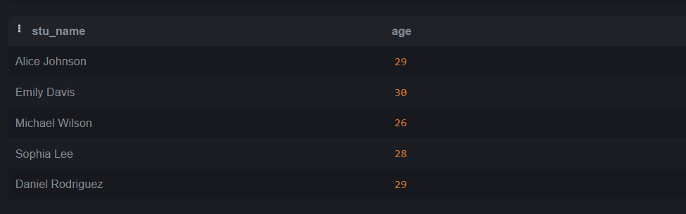

**8. Grouping and Calculation**

Create a query to group the "student_table" by the "Department" and "Gender" columns and calculate the average GPA for each combination.

**Query:**

SELECT Department,

Gender,

AVG(GPA) AS average_gpa

FROM student_table

GROUP BY Department, Gender;

**Output:**

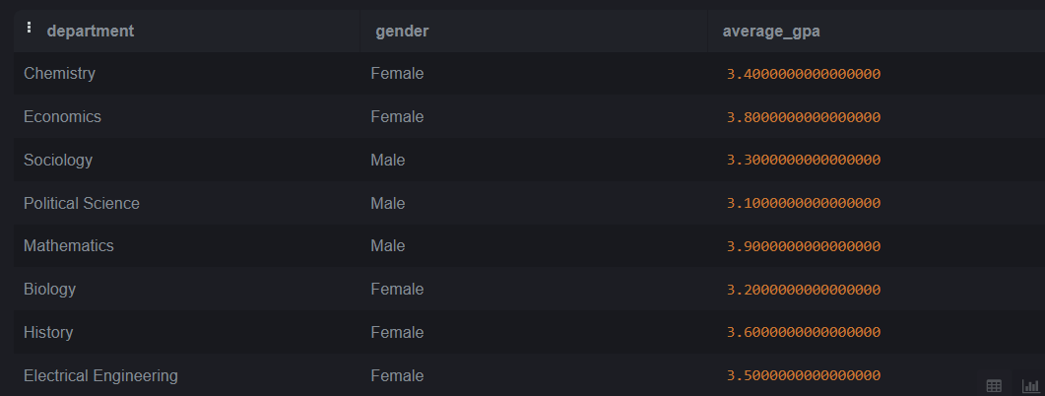

**9. Table Renaming**

Rename the "student_table" to "student_info" using the appropriate SQL statement.

**Query:**

ALTER TABLE student_table

RENAME TO student_info;

**Output:**

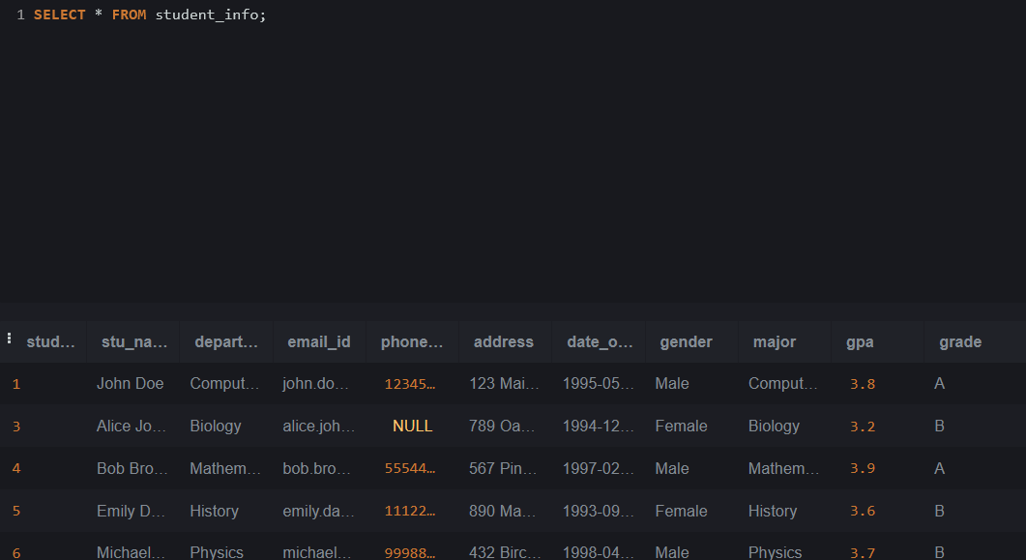

**10. Retrieve Student with Highest GPA**

Write a query to retrieve the name of the student with the highest GPA from the "student_info" table.

**Query:**

SELECT Stu_name

FROM student_info

ORDER BY GPA DESC

LIMIT 1;

**Output:**

